# Apply filters to SQL queries

## Project description

In this project, the aim is to extract specific data from a database to address security concerns and update computer records. The tasks include retrieving information on failed login attempts outside business hours, analyzing login attempts on specific dates, and filtering logins not originating from Mexico. Additionally, we need to gather details about certain employees in the Marketing department, employees in either the Finance or Sales departments, and those not in the Information Technology department. These queries help us identify unusual activity patterns, monitor departmental access, and ensure the integrity and security of the company's IT systems.

## Retrieve after hours failed login attempts

To retrieve the failed login attempts that occurred after business hours, it need to filter the data based on two conditions: the time of the login attempt and the success status of the login. Specifically, you want to identify unsuccessful login attempts that were made after 18:00 (6 PM).

Here's an SQL query that accomplishes this:

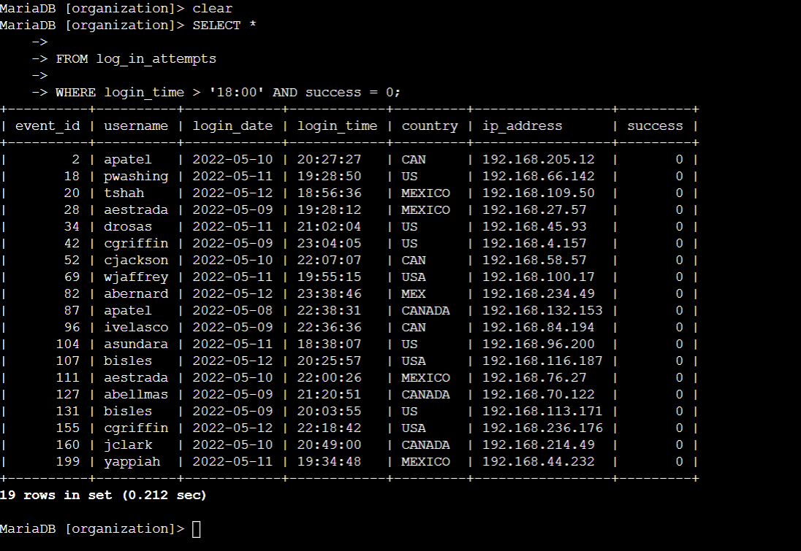

In this query:

**success = 0** filters for failed login attempts, as 0 represents FALSE in the success column. **login_time > '18:00'** filters for login attempts made after 18:00.

This query will return all records from the log_in_attempts table where the login attempt was unsuccessful and occurred after the end of regular office hours.

## Retrieve login attempts on specific dates

To investigate the suspicious events, it is need to retrieve all login attempts that occurred on '2022-05-09' and the day before, '2022-05-08'.

We can use the OR operator in The SQL query to filter for these specific dates.

Here's the SQL query:

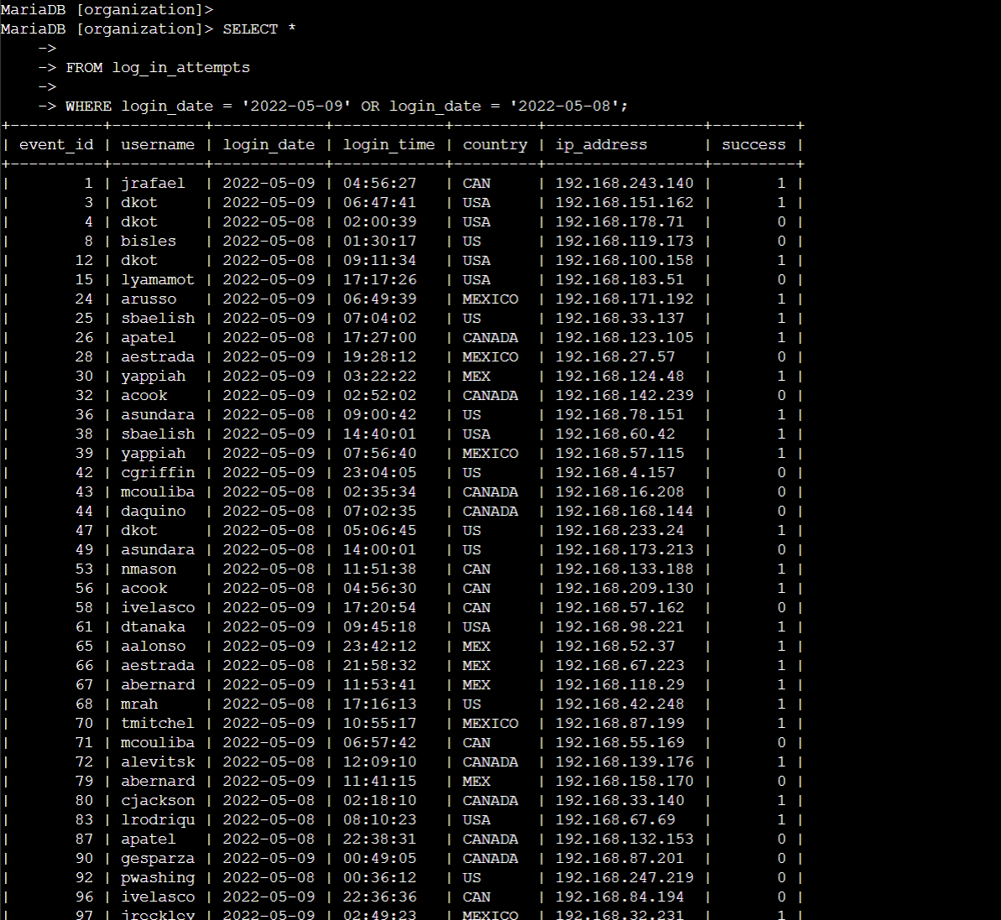

In this query:

**login_date = '2022-05-09'** retrieves login attempts that occurred on the specified date. OR **login_date = '2022-05-08'** adds the condition to include login attempts from the previous day.

This query will return all records from the log_in_attempts table where the login attempts were made on either '2022-05-09' or '2022-05-08', providing a comprehensive view of activities around the time of the suspicious event.

## Retrieve login attempts outside of Mexico

To retrieve login attempts that did not originate in Mexico, we can use the NOT and LIKE operators in your SQL query to exclude entries where the country field starts with 'MEX', which covers both 'MEX' and 'MEXICO'. The matching pattern 'MEX%' will help filter out these entries.

Here's the SQL query:

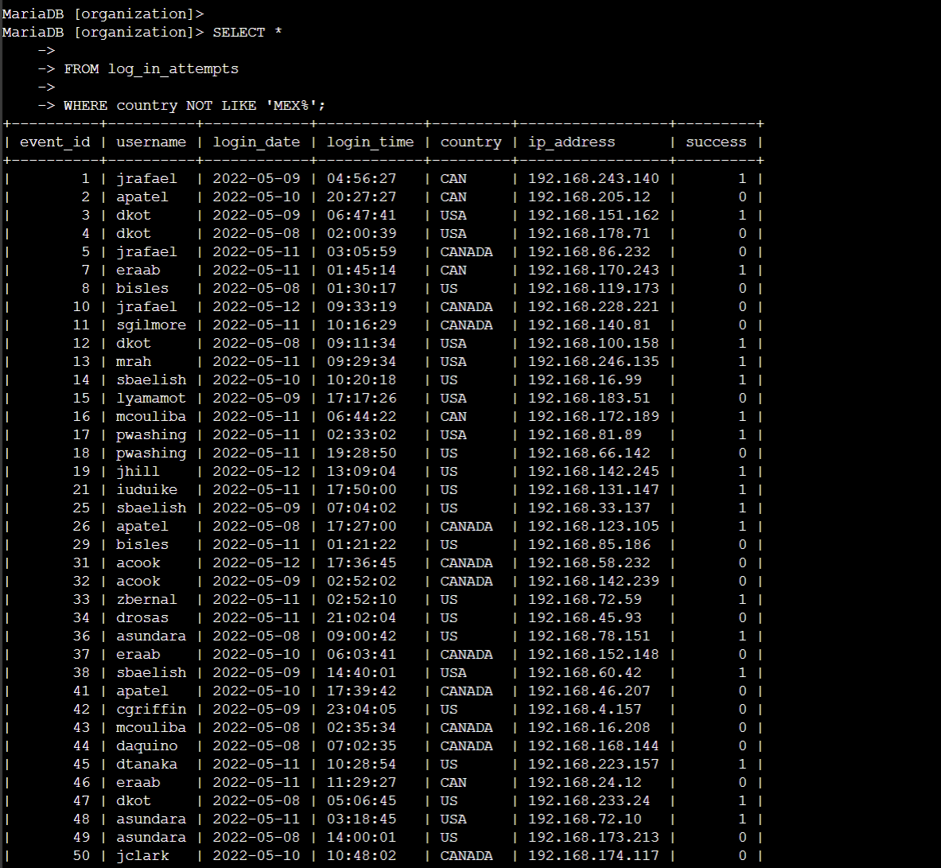

In this query:

country NOT LIKE 'MEX%' filters out records where the country column starts with 'MEX', excluding all variations such as 'MEX' and 'MEXICO'.

This query will provide all login attempts from locations other than Mexico, aiding in the investigation of potentially unauthorized access from other regions.

## Retrieve employees in Marketing

To retrieve information about employees in the 'Marketing' department who are located in the East building, we can use the WHERE clause in the SQL query to filter by the department and the office location. Specifically, the office location should match the pattern 'East-%' to include all offices in the East building.

Here is the SQL query:

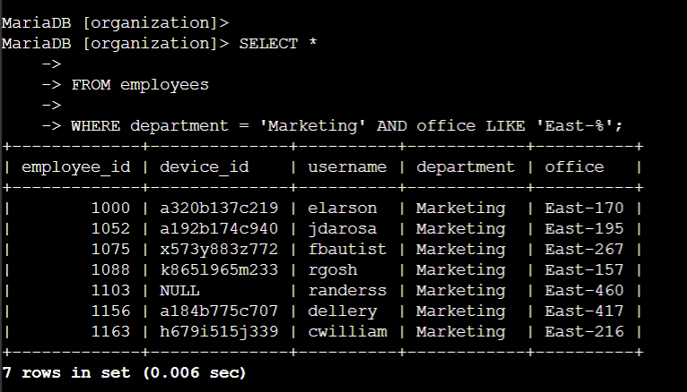

In this query:

**department = 'Marketing'** filters for employees in the Marketing department.

**office LIKE 'East-%'** filters for employees located in any office in the East building, where office names start with 'East-' and may include additional numbers or characters.

This query retrieves all relevant records from the employees table, including details about the employees in the specified department and location, which will be useful for updating their machines.

## Retrieve employees in Finance or Sales

To retrieve information about employees in either the 'Finance' or 'Sales' department, we need to use the OR operator to specify both conditions clearly. Each condition should explicitly reference the department column.

Here is the SQL query to achieve this:

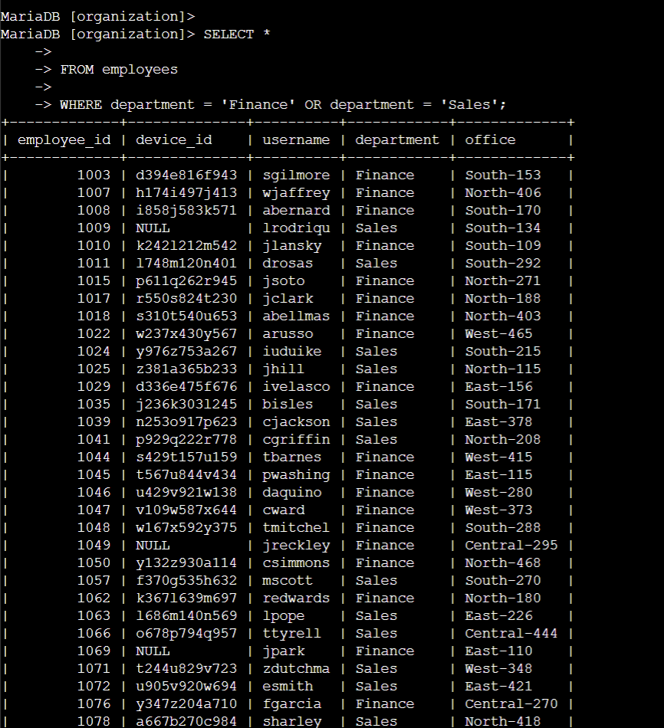

In this query:

**department = 'Finance'** retrieves records for employees in the Finance department. OR **department = 'Sales'** includes records for employees in the Sales department.

This query will return all records from the employees table for those who belong to either the Finance or Sales department, facilitating the necessary updates to their computers.

## Retrieve all employees not in IT

To retrieve information about employees who are not in the 'Information Technology' department, we can use the NOT operator in the SQL query to exclude records from that specific department.

Here is the SQL query:

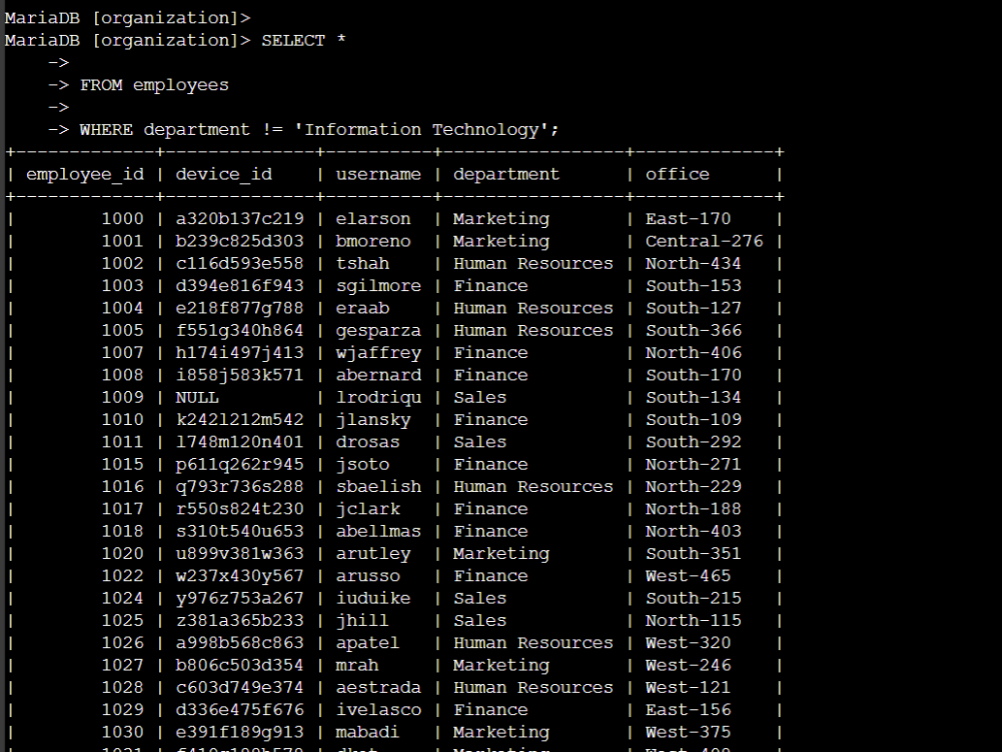

in this query:

**department != 'Information Technology'** filters out employees who belong to the Information Technology department, thereby retrieving records for all other departments.

## Summary

To support your team’s needs, several SQL queries are required: First, retrieve failed login attempts after business hours by filtering out unsuccessful logins occurring after 18:00. Next, for analyzing suspicious activity, extract login attempts on '2022-05-09' and '2022-05-08'. To investigate logins from outside Mexico, use a query to exclude records where the country field starts with 'MEX'. Additionally, obtain information about employees in the 'Marketing' department located in the East building offices, and gather records for employees in either the 'Finance' or 'Sales' departments. Finally, to focus on non-IT staff, filter out records for employees not in the 'Information Technology' department.